**SRI A.S.N.M GOVERNMENT COLLEGE (A), PALAKOL**

**DEPARTMENT OF COMMERCE**

**2021-22**

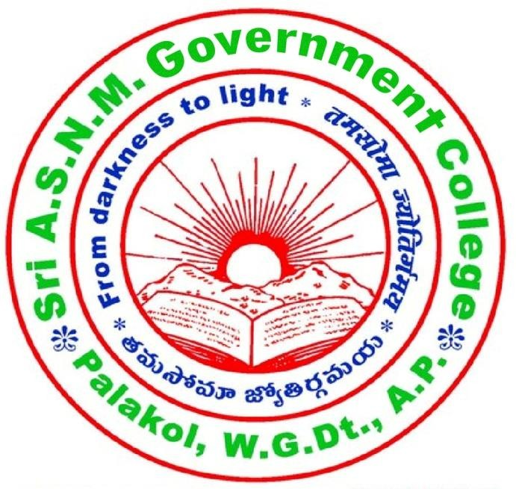

**“WORLD CONSUMER RIGHTS DAY”**

**ON**

**15th March 2022**

# MARCH 2022

# WORLD CONSUMER RIGHTS DAY

Department Of Commerce Organized an wariness program on 15th MARCH Celebrating the “INTERNATIONAL CONSUMER RIGHTS DAY”. This program is aim that creating awareness on product, quality, durability, Accuracy, pricing &standards. Dr.T.Raja Rajeswari, principal as attended the has a Chief Guest. Speaking on the occasion she emphasized on the importance and significance on consumer rights and the importance of the role of goods & services .Dr B.Subbalakshmi HOD of Telugu, Dr.Ch.Usharani incharge of commerce Ravi kumar computer applications incharcge department Manmadharao, Swarnalatha, Durgeswari, Ashajyothi along with 50 Students from across tree participated in this program.